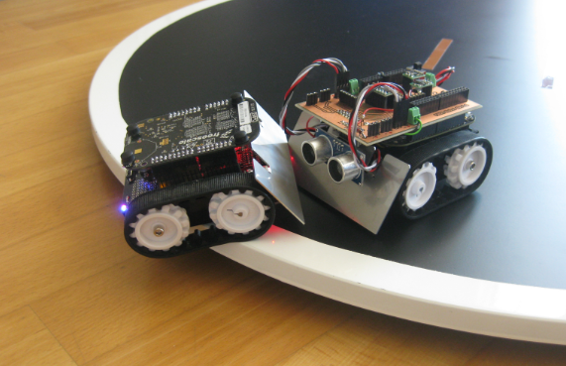

**ADASTRA’25**

R

U

L

E

B

O

O

K



PRIZE MONEY

₹ 12K

ROBO SUMO



_adsatra_eatm

DESCRIPTION:

In the Robo sumo competition, two robots compete in a head-to-head match. The robo sumo matches are like traditional human sumo matches. No use of weapons is allowed in robo sumo. It's a pushing match between two robots that will try to force each other towards borderline.

BOROT SPECIFICATION:

1. The Bot should fix in a box of dimension 300mm X 300mm X300 mm (l x b x h) at every given point of the race.
2. The total weight of the robot should no more than 5kg.
3. Maximum voltage most not exceed 12 volts.
4. The Bots cannot be constructed using readymade Lego kits though use of readymade gear assemblies is allowed. Violating this clause will lead to disqualification of the team.
5. Ground clearance should be maintained.

ROBOT CONTROL SPECIFICATIONS:

1. The bot can be controlled either by wired or wireless remote control mechanism at all stages of the game.
2. Ther should be binding capacity between transmitter and receiver.
3. For wireless the team must have carry at least four channel wireless remote control circuit .

JUDGING CRITERIA:

1. Matches are 1v1 battles.
2. Each match has of fixed time limit. The robot that successfully pushes its opponent out of the arena wins.
3. If neither robot is pushed out within the time limit, the match will go to a judge's decision based on control, aggression, and style.

NOTE: Rules are subject to change if organizers deem it fit.

RULES AND REGULATIONS:

1. All the participants should carry valid ID cards of their institutions.
2. Strength of the group not exceed 4.
3. Only 2 members of a team are allowed to stay around the arena (one for controlling and one for assisting).
4. The judges decision will be final and beyond arguments.
5. We are not responsible for any kind of damage to the robots in the game field.
6. Participant can not change the design, once the robot registered for the event.

NOTE: Rules are subject to change if organizers deem it fit.

Contact Details: